We first met Bernard Kaunda, from Mzuzu Coffee Planters Cooperative Union, when he visited Scotland at Trade Connections – a trade fair and seminar that was held at Glasgow’s SECC on November 1st, 2006, which aimed to increase trade between Scotland and Malawi.
At the time we had a Fair Trade shop in Greenock, called Fayretrade, and after sampling Bernard’s coffee which was grown, roasted and packaged in Malawi, in its distinctive gold package, we just knew that we had to retail it. We subsequently discovered that this was not available in the UK, as only the green bean was being exported.
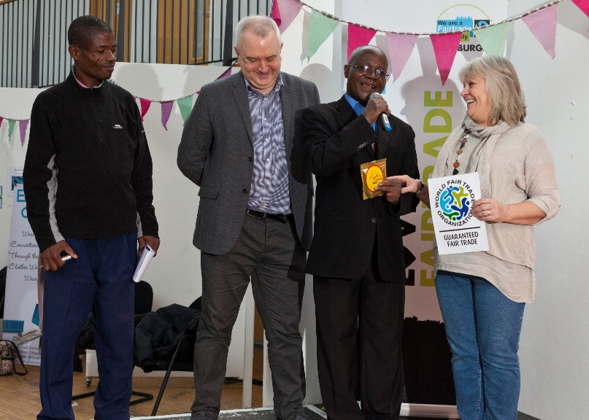
Fast forward 12 years, during which time we had closed the shop but started Fair Trade Scotland as a WFTO Fair Trade importer, and Mzuzu Coffee had become FLO certified in 2009. Bernard, now acting CEO and his colleague Christopher were invited back to Scotland, by the Scotland Malawi Partnership and Scottish Fair Trade Forum to celebrate Fairtrade Fortnight 2018. You can see Bernard’s announcement - at the Edinburgh Fairtrade event on March 11th 2018 here: https://youtu.be/gDuucAAfjPI
With impeccable timing, Fair Trade Scotland has now been announced as the 174th WFTO Fair Trade Guaranteed member, which has allowed us to take this next step in our journey to bring value added products to the market through this route. We will be using the WFTO Guaranteed Fair Trade label on the packaging – along with the FAIRTRADE Mark – both marks certifying and verifying that the 10 WFTO principles are adhered to in the entire supply chain.
The FINE criteria states that Fair Trade is a trading partnership, based on dialogue, transparency and respect that seeks greater equity in international trade. It contributes to sustainable development by offering better trading conditions to, and securing the rights of, marginalised producers and workers – especially in the South.
Bernard Kaunda, said that since coming to Scotland in 2006 it has always been their hope to sell the finished product, not just the exported green bean (which is roasted and packaged by suppliers of coffee in the UK) which will give a greater share of the final consumer price to the producers.
We have started the process to make this a reality, but we now need a commitment from 500 people willing to ‘buy into’ the venture, paying a price that reflects the true costs of an audited Fair Trade supply chain.
The commitment to purchase a 250g bag of MZUZU Gold Standard coffee, whilst building capacity at the producer’s pace, will see a ‘speciality’ product enter the market to complement the many varieties of exported ‘green bean’ coffee currently on sale.
As we are in the early stages, we are looking for those willing to join ourselves and Bernard on this journey and ‘a note of interest’ would be welcome. When we reach our target of 500 we will send out a FIRST 500 email giving a complete breakdown of costs – which will include postage & packaging and the final purchase price.
There will be regular updates by email and we hope to have the final label for the packaging – complete with logos – for a launch – venue to be announced - on September 25th, when the International Charter of Fair Trade will be launched worldwide. If you are interested please email: Eve.broadis@fairtradescotland.co.uk with FIRST 500 in the subject line.

