The UK’s development finance institution and Malawi

About CDC, the UK’s development finance institution
- CDC Group is the UK’s development finance institution (DFI)– wholly owned by the Department for International Development. Our mission is to support the building of businesses throughout Africa and South Asia, to create jobs and make a lasting difference to people's lives in some of the world's poorest places. We were founded in 1948, making us the world's first DFI.

- CDC is focused on helping to deliver the UN Sustainable Development Goals. We work to contribute to all the Goals but have a strategic focus on Ending Poverty (Goal 1) and Decent Work and Economic Growth (Goal 8). At the end of 2018, we were invested in 698 business in Africa and 344 businesses in South Asia. These businesses:
- provided employment for over 850,000 people.
- had hired 32,090 people that year (2018).
- had created jobs at an average annual rate of 5.8% over the past five years, compared to a regional average growth rate of 3.1%.
- paid $4.5 billion in employee wages (2018).
- paid $3.24 billion in taxes which could be reinvested by governments in Africa and South into public services – helping in the long-term to reduce aid dependency (2018).

CDC and Malawi
- CDC has a long history in supporting development in Malawi. We made our first investment in the country in 1949 and our investments, mainly in the agricultural sector, have supported the livelihoods of many hundreds of thousands of people across the country.
- For example, in 1978 we invested in the National Seed Company of Malawi (NSCM). By 1984, Malawi was not only self-sufficient in seed supplies for all its major crops, and therefore no longer reliant on an unpredictable supply from other countries, but it also had developed a thriving export trade.

- Supporting Malawi today. Malawi is a particular focus of our Impact Accelerator programme. This Impact Accelerator programme invests directly in businesses to create economic opportunity and jobs, and increase access to basic goods and services, especially in remote areas or fragile states. This programme allows CDC to innovate new approaches to unlock impact.

Examples of CDC’s investments in Malawi

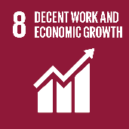
- Jacoma Estates Ltd – supporting inclusive and climate-smart agriculture
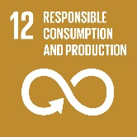
In 2016 CDC invested $8 million in Jacoma Estates Ltd. The investment will help this inclusive agribusiness expand its production of high value macadamia nuts, birds eye chili and paprika in northern Malawi. The investment will benefit local small holder farmers through offtake and provision of irrigation infrastructure for up to 100ha of neighbouring smallholder land. We will support Jacoma in its development of sustainable outgrower schemes and strengthen its environmental and social practises, becoming a model for sustainable inclusive agriculture.

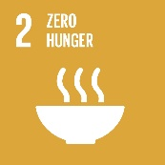
- Kamponji – tackling nutrition and micronutrient deficiencies
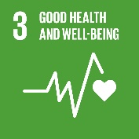
In 2017, we invested $15 million in Kamponji Enterprises Ltd (KEL), a vertically-integrated poultry business in Malawi involved in the production, processing, distribution and retail of table eggs, broiler day-old-chicks and animal feed. The aim of the investment is to tackle nutrition and micronutrient deficiency in Malawi. Currently 63% of children under five and one third of women in Malawi suffer from anaemia (DHS 2016) and eggs are the cheapest and most readily available source of protein and iron. KEL business model involves educating Malawian small holders on how to start sustainable and profitable small-scale broiler operations in their communities to improve livelihoods and increase resilience to rain-dependent agriculture.

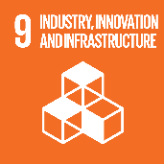
- 14Trees – tackling climate change through environmentally-friendly bricks
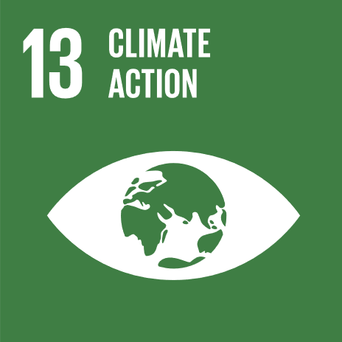
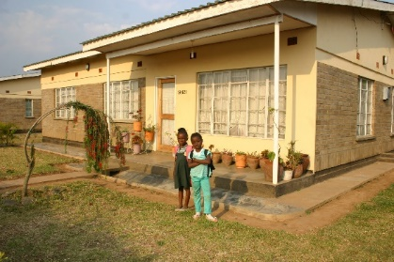
In 2015, we undertook a joint venture with LafargeHolcim, to create 14Trees, with the aim of producing an environmentally-friendly alternative to traditional clay burnt bricks. The bricks, known as Durabrics, are produced without firing, reducing the amount of wood compared to clay burnt bricks by 14 trees per house. Less wood burning helps to address climate change, while also meeting the growing demand for affordable housing. The bricks are already used in Malawi, Rwanda, Tanzania and Zambia. We are also supporting management to develop a franchisee model to drive uptake and further employment.

Further information - Please contact: Andrew Palmer, Head of Global Affairs, M. +44 (0) 7990 036 970; E. apalmer@cdcgroup.com

