Five year Plan 2019 – 2024
Background
We have built strong partnerships in Blantyre. We have made very effective use of the government funding since 2015 to build a strong framework. There is emerging evidence that our approaches are making a difference. We have evidence of improved engagement with teachers, headteachers and primary education advisers and increased use of books through our libraries.
MLOL sits well within the UN Sustainable Development Goals. In particular, Goal 4 Quality of Education which is to ensure inclusive and quality education for all and promote lifelong learning. When people are able to access quality education they can break the cycle of poverty. We firmly believe that education both in Glasgow and in Malawi helps to reduce inequalities and to reach gender inequality. It also empowers people everywhere to live more healthy and sustainable lives. Education is also crucial to fostering tolerance between people and contributes to more peaceful societies.
We have a number of secondary schools which have built strong partnerships: Knightswood Secondary School with Lunzu Secondary School, Springburn Academy with Chichiri Day Secondary School, Rosshall Academy with a range of primary schools, St Roch’s Secondary School with CI Secondary School and Holyrood Secondary School with a range of primary schools and Stella Maris Secondary School. Smithycroft Secondary School is planning to send a small group next year, potentially along with St Roch’s Secondary School. These partnerships impact very positively on Glasgow’s young people. They work together in Glasgow using global education to explore poverty both in their own context and in Africa. They then visit Malawi and either work alongside Malawian young people exploring issues which effect young people globally sharing their own experiences and/or they work on projects to improve the infrastructure in schools and early childhood development centres.
Our teachers who have visited Malawi have built strong connections. The evaluations provide evidence of a renewed focus on the impact of effective learning and teaching. Their experiences also influence their teaching in Glasgow with an increased emphasis on global education permeating their teaching.
The Malawian teachers who visit Glasgow report that the experience has extended their learning, in particular, the use of books to develop literacy and the importance of physical activity to support learning. Glasgow’s children have thoroughly enjoyed having them in their schools and they have deepened their understanding of Malawi through the visits.
However, it is not possible to sustain all elements of the project to date without government funding. There will not be groups of teachers going in September nor will Malawian teachers come to Glasgow.
The Way Forward
We will continue to have one principal objective:
To improve education in Malawi and Glasgow
We will achieve this through continued strong partnership working between Education Services in Glasgow City Council and Blantyre Urban and Blantyre Rural Districts.
We will focus on improving learning and teaching through providing increased professional development opportunities for teachers, headteachers, primary education advisers and locally-based inspectors.
Our goals will be:
To deliver professional learning on
- leadership to every primary headteacher in Blantyre Urban and Rural Districts; and
- learning and teaching and effective use of a library to teachers from every primary school in Blantyre Urban and Rural Districts.

Activities will be supported financially through the charity, Malawi Leaders of Learning and we will continue to fundraise.
Activities
There will be two visits per year to support professional learning. School visits will continue in June and, on occasion, in September.
In October and in February, a small team of education professionals will visit Blantyre to deliver professional learning. The professional learning can be delivered in Teacher Development Centres (TDCs) to reduce travel commitment for participants. This is also where training takes place when delivered as part of the zone’s or District’s CPD programme, which reinforces our goal to make MLOL sustainable.
Headteachers and PEAs would participate in a two stage programme – the first in October and the second in February.
The professional development on learning and teaching and the use of libraries will also take place in TDCs and be free-standing, that is, the sessions in October and February will not be linked. We will invite teachers from the previous professional learning to share their practice and learning in the next professional learning session and in so doing we will build the confidence and enthusiasm of teachers.
We will develop materials for both the headteacher and teacher training. We will also develop materials for an ‘Into Headship’ programme for depute headteachers which could be delivered by Malawian senior leaders.
Each headteacher who attends the training will receive a copy of a book on primary teaching methods to support their professional learning. (McMillan, Primary Teaching Methods)
Teachers who attend the training will receive posters to be used as learning prompts.
MLOL Professional Learning Teams
Each team will consist of between four and six people. They will work in teams to deliver the professional learning. One or two staff will come from Education Scotland. The other members of the team will be drawn from the pool of previous MLOLs who have been to Malawi to deliver learning and teaching training. The team will have a balance of skills to enable them to deliver leadership training and training on learning and teaching, including effective use of a library.

Footprint of MLOL Activities
Day 1: travel (Friday)
Day 2: arrive in Blantyre
Day 3: preparation (Sunday)
Day 4: Monday – headteacher training with link PEAs 20 to 25 participants – 2/3 staff delivering
Day 4: Monday – teacher training with link PEAs in attendance 20 to 25 participants – 2/3 staff delivering
Day 5: Tuesday – headteacher training with link PEAs 20 to 25 participants – 2/3 staff delivering
Day 5: Tuesday – teacher training with link PEAs in attendance 20 to 25 participants – 2/3 staff delivering
Day 6 – Wednesday flexible day to prepare and review evaluations from day 4 and day 5
Day 7 – Thursday – headteacher training with link PEAs 20 to 25 participants – 2/3 staff delivering
Day 7 – Thursday - teacher training with link PEAs in attendance 20 to 25 participants – 2/3 staff delivering
Day 8 – Friday – Thursday – headteacher training with link PEAs 20 to 25 participants – 2/3 staff delivering
Day 8 - Friday – teacher training with link PEAs in attendance 20 to 25 participants – 2/3 staff delivering
Day 9 – Saturday – travel home
Venues and catering for professional learning
The professional learning will take place in Teacher Development Centres (TDCs). The Senior Inspector, in partnership with the Coordinating PEAs, will arrange the scheduling of the training ensuring that the venues are booked and participants are invited. The Senior Inspector will maintain a record of all those attending.
The MLOL team will provide the refreshments and snacks for the training. Bottles of water for all participants along with biscuits can be bought at Shoprite or another supermarket.
Each participant will be provided with MKW2000 to cover lunch and travel. No per diems will be paid.
Transport
Transport will be provided through the MLOL car and minibus. MLOL will provide funding for a daily driver allowance and fuel.
Additional information
Gifts should be taken, such as pens and badges from Glasgow City Council. All course material will be provided along with training, as appropriate.
Flights and accommodation (bed and breakfast at Kabula Lodge) will be paid for by the MLOL charity. MLOLs will be expected to pay for their own meals beyond breakfast.
Books (MacMillan, Primary Teaching Methods) will be organised through Anglia Books to issue to headteachers. This will be done in advance of arrival.
The Senior Inspector and coordinating PEAs in Malawi will organise the participants and this information will be provided in advance.
We are continuing to pursue a donor(s) to support the continued development of libraries. Our positive relationships with Anglia Books means that we can provide culturally-appropriate books as part of a recognised African reading scheme. The headteachers’ book we are providing is designed for African teachers. We also link with the Malawian National Library Service (MNLS) to access Book Aid books. This comes with a cost due to funding challenges being experienced by MNLS.
We will also continue to keep Scottish Government informed as our work will continue to contribute to the overall contribution of Scotland to Malawi. Their international development team continue to be supportive of our work, for example, in March 2019, we were offered £4,000 to support the development of libraries.
As a charity, MLOL will continue to raise funds to support all aspects of the project. The inclusion of Education Scotland with MLOL will help support their international development and it is hoped that they too would fundraise for the charity as part of their planned approach to charity-giving as an organisation.

Maureen McKenna
Chair of Trustees, Malawi Leaders of Learning

Appendix 1
Partnership with Education Scotland
Policy context for International Engagement
Education Scotland has established a clear international strategy which is available on its website International Engagement .
The strategy has four key drivers:
We believe that our international engagement strategy must:
- Increase the global competences of all learners in Scotland;
- Enhance national education policy and practice applying lessons learned from other countries to drive excellence and innovation in Scotland;
- Share practice internationally and engage in partnership working with other international organisations; and
- Contribute to the improvement of education in other countries particularly in the developing world.
Key driver 4: Contribute to the improvement of education in other countries particularly in the developing world.
Education Scotland is committed to making a positive contribution to improving the life chances and circumstances of learners living other countries, including in developing and newly-industrialised countries. These include focused, strategic advice and support in high-priority area such as national policy and infrastructures, learners’ experiences, teacher effectiveness, leadership, the curriculum, attainment and equity.
We will:
- Work in collaboration with the Scottish Government Directorates of International Development and Learning to support the delivery of national Statements of Intent, including recent agreements with France and Malawi;
- Work closely and in partnership with other key organisations, British Council, the Scotland Malawi Partnership and Creative Scotland to provide appropriate targeted educational support in identified Scottish Government priority countries, including Malawi, Rwanda, Zambia and Tanzania, Pakistan, Bangladesh and a number of Indian jurisdictions;
- Formalise and sign an agency to agency high level five year cooperation with the Government of the Republic of Malawi to support educational improvement and increase the life chances of children and young people; and
- Consider commissions to improve key aspects of education in other countries and jurisdictions including approaches to inspection, assessment and undertaking joint reviews.

Appendix 2
Malawi and Malawian Education
Background information
Malawi has a proud history with strong links with Scotland. It is one of the poorest countries in the world with 50.7% of the population living below the poverty line and 25% living in extreme poverty.
Its GDP per capita is around US$438 (2019) compared to US$43,200 in UK, US$7,562 in South Africa, US$2,500 in India, US$1,141 in Mozambique, $US5,400 in Nigeria and US$776 in Rwanda.
A headteacher earns on average US$80 per month.
It has a population of around 18 million. However, the challenge the country faces is that the bulk of the population are under 18. The next two graphs illustrate this starkly. The first shows the UK population and the second is Malawi.
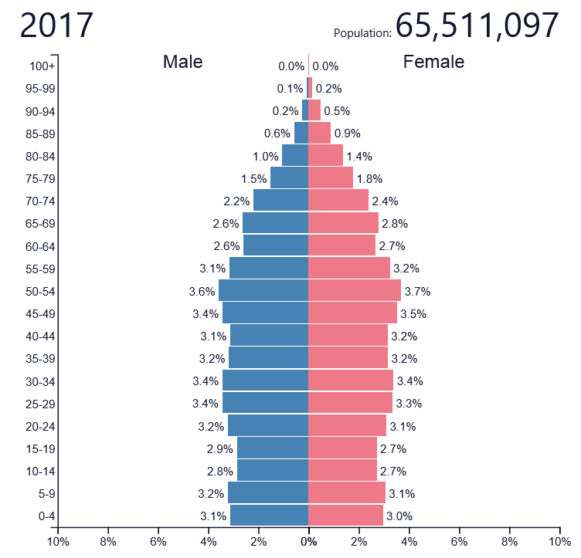
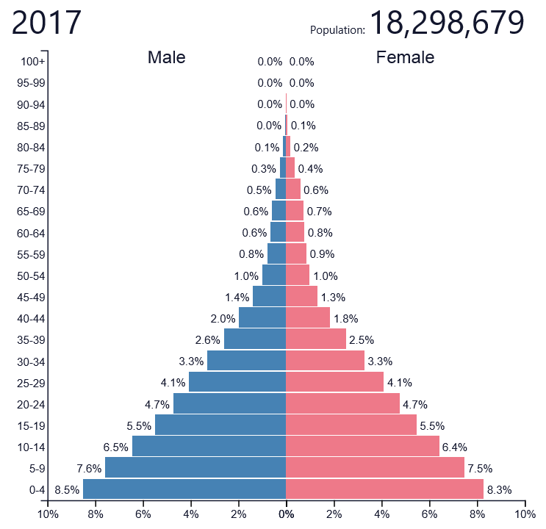
In the UK, in 2017, life expectancy was 79.2 years for a man and 82.9 years for a women. In Malawi, life expectancy is estimated as between 54.5 years and 63 years.
Malawi has one of the highest HIV prevalences in the world although it has made impressive progress controlling its HIV epidemic in recent years. Prevalence is now 9.6% overall.
In some townships, HIV prevalence can be as high as 30%. 50% of new HIV infections affecting those aged 15 to 17. Around 1.6% of all children are HIV.

Malawi education
Education is a big priority for Malawi. The Ministry of Education, Science and Technology (MoEST) has responsibility for all school education.
Primary education is universally available and free. Secondary education is selective and comes with a cost. Around 10% of pupils (known as learners in Malawi) go to secondary school.
The curriculum is quite rigid in secondary schools and is very exam-focused at every stage. There are four years of secondary education.
Children start primary school at age 6 if they are able to access it. In more rural areas, children may not start school until they are age 8-10 just because they may not be physically able to walk the required distance to get to school. They complete 8 years of primary education – known as Standard 1, Standard 2 – up to Standard 8. There is a steady drop-out rate as children progress through primary school. This is due to family commitments, care of younger siblings, care of fields (much of Malawi survives on subsistence farming) and, in the case of girls, early pregnancy.
There are tests at the end of each primary year and the exams at the end of each year and learners cannot progress unless they pass. Standard 8 are the most important because these decide whether or not learners get into secondary school and what quality that secondary school is.
Many primary schools do not have enough classrooms for all learners. Although there have been some improvements, some classes need to be taught outside. The rainy season impacts on the continuity of children’s learning.
Many classrooms do not have desks and learners have little equipment. There are few resources in the school. There is not a culture of literacy in schools.
The main language of instruction at Standard 1 to 3 is Chichewa. From Standard 4 onwards it is English. However, in some schools English is not used as often as it should and this is a particular problem in rural areas. English is the language of instruction in secondary schools.
Classes are large – classes can have over 200 learners all sitting on the floor in a classroom. In 2018, MLOLs worked in a school where there was a Standard 5 class with 400 learners.
There is no provision for feeding learners during the day except through organisations, such as Mary’s Meals.
There are under 6 centres, but they are the responsibility of a different Ministry (Ministry of Women) and there are relatively few of them. Mary’s Meals were running a number of them but this is evolving. They are staffed by volunteer caregivers who tend to be older local women. They are ‘paid’ by being given likhuni phala (porridge). The Church also runs some of these for vulnerable children in some Districts.
Malawi is split into Regions and then each Region is split into Districts. Secondary schools are managed at Region level and primary schools managed at District level.
There are Primary Education Advisers in Districts who are broadly equivalent to quality improvement officers.
There are locally based inspectors who are part of District management teams. A District Education Manager heads up each District.
The charity, Link Community Development (LCD), were commissioned by the Scottish Government to develop the Malawian National Education Standards. These were published in 2015 and are broadly based on HGIOS – they were designed by a former HMI working with Malawian inspectors. MLOL paid for 500 copies to be made so that each primary school in Blantyre Urban and Primary had at least one copy each.

Blantyre Urban and Blantyre Rural
There are currently 61 primary schools in Blantyre Urban and 164 primary schools in Blantyre Rural. The schools vary considerably in size, from a very small rural school of 250 pupils to a large urban school of over 10,000 pupils. The number of schools is increasing as the population increases.

Drawn from UN Sustainable Goals www.un.org/sustainabledevelopment

