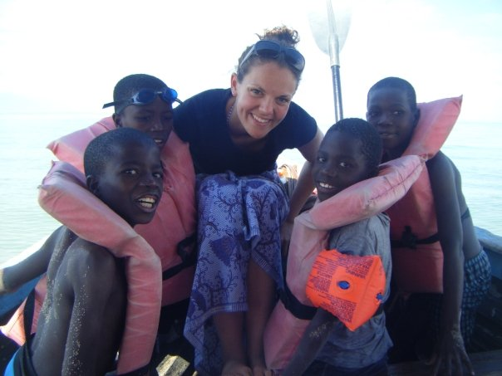
Africa project gives global citizenship a boost
A probationer who set up a charity for children in Kenya and Malawi is bringing her experiences to the classroom
By Henry Hepburn 23 July 2010
As a qualification for teaching children about the wider world, it's hard to beat: Caroline Dickson set up her own international charity at the age of 19.
Drawing on her work improving the future of orphans in Malawi and Kenya, the Strathclyde University B.Ed graduate will go into her probationary year at Glasgow's Blairdardie Primary next month with supreme knowledge of what "global citizenship" actually means.
Miss Dickson, now 22, was initially inspired by her father, a GP who worked in Kenya in the 1980s. When she left Jordanhill School in Glasgow in 2005, where she was head girl but the youngest pupil in her class, she thought she was "a bit young" for university. So, rather than putting her feet up or ambling round the backpacker trail on a gap year, she signed up with the Project Trust charity.
That led to a year running an orphanage of 25 primary school children in Malawi - with an Edinburgh University student one year her senior, Abby Higgins, and American director Theresa Harawa - and teaching a class of 50-plus children aged two and three.
As a pupil, Miss Dickson had become frustrated in Advanced Higher geography, when ideas for sanitation and farming projects garnered high marks but were never destined to be put into practice: "It's great to get an `A', but I wasn't helping anyone - and I didn't need any help locating a long-drop toilet in Scotland."
She "absolutely loved" being able to do something practical in Malawi, and could not stop thinking about the experience back home - to the point where her family became annoyed by the amount of sentences starting with "When I was in Malawi ."
She sent aid parcels from Scotland, but had a nagging feeling that this did not go far enough. In 2007, eight months after her return from the south-east African country, Kenyawi Kids was registered as a charity by Miss Dickson and Miss Higgins. Last year it raised pound;14,000.
But the charity does not merely hand over cheques: it prioritises "income- generation projects" which help people to thrive under their own steam. Its most recent update, in May, recounted a successful year for Yamikani Orphanage after money from the charity bought some chickens. Profits from surplus hens and eggs will allow the orphanage to buy goats, without funding from Kenyawi Kids.
Children back in Scotland have also benefited: "I've used my experiences from Africa in my school placements to try to enhance children's sense of global citizenship," says Miss Dickson.
She played the "two truths and a lie" game with P2s, telling them she loved tennis, didn't like bananas and used to live in Africa. Every child guessed the last statement was false, and so began an animated discussion about how a white Scottish woman could possibly end up living in such a place.
She can also counter nascent stereotypes about African children, stemming from the distressing images used by charities: "So much of what they see is children crying. I can show them photos of African children throwing water bombs and running about."
Miss Dickson is excited by Curriculum for Excellence and the freedom it gives her to explore global citizenship with pupils. She is disappointed by the cynicism CfE attracts in some quarters, contrasting the gratitude shown to policymakers in Malawi: "When a new curriculum came in there, everyone thought it was so fantastic that someone wanted to do things and make a difference."
Miss Dickson insists any teacher with a curiosity about the world has the potential to thrive in global citizenship. A project for her B.Ed, however, uncovered a widespread lack of confidence in teaching global issues.
She surveyed her classmates, who largely blamed the university for not doing more on global citizenship, and was struck by how few seemed to realise they could equip themselves with the tools they needed, by reading newspapers or travelling abroad.
Some could not identify any global issues. Most got opinions about Africa from the media, yet might only watch the news when the channel Five bulletin came on after Neighbours. Based on limited knowledge, there was a bleak consensus that they could do little to improve the plight of impoverished Africans.
Miss Dickson has already spent time at Blairdardie Primary, on placement with a P2 class, and staff are delighted to see her return to the Old Drumchapel school.
P2 teacher Vhairi Cochrane believes Miss Dickson's charity work will prove invaluable to the P6 class she takes in her probationary year: "You can't beat life experience."
In October Miss Dickson will begin a two-year masters in development education, through the Institute of Education in London, with a dissertation on Malawi. After her probationary year, she intends to go back to work in the country for a long stint, building on the contacts she has established - including First Lady Callista Chimombo, the mother of a good friend.
Yamikani Orphanage is on the outskirts of Blantyre, named after the home town of Scottish missionary David Livingstone. When Miss Dickson tells children she is Scottish, they ask if she is a descendant of Livingstone and show a thirst for knowledge about Scotland.
Improving life for poor Africans should be about building on this mutual curiosity, she believes: "It's not all `Let's just fundraise and send stuff'. Let's learn about how they live, and they can learn about us."
www.kenyawi-kids.com
henry.hepburn@tes.co.uk.
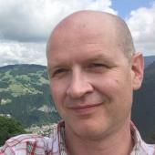Henry Hepburn
Henry Hepburn is the news editor for Tes Scotland. Twitter: @Henry_Hepburn

