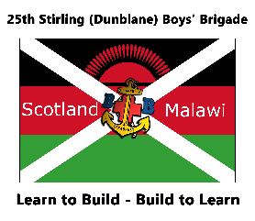
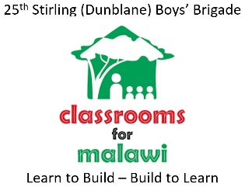

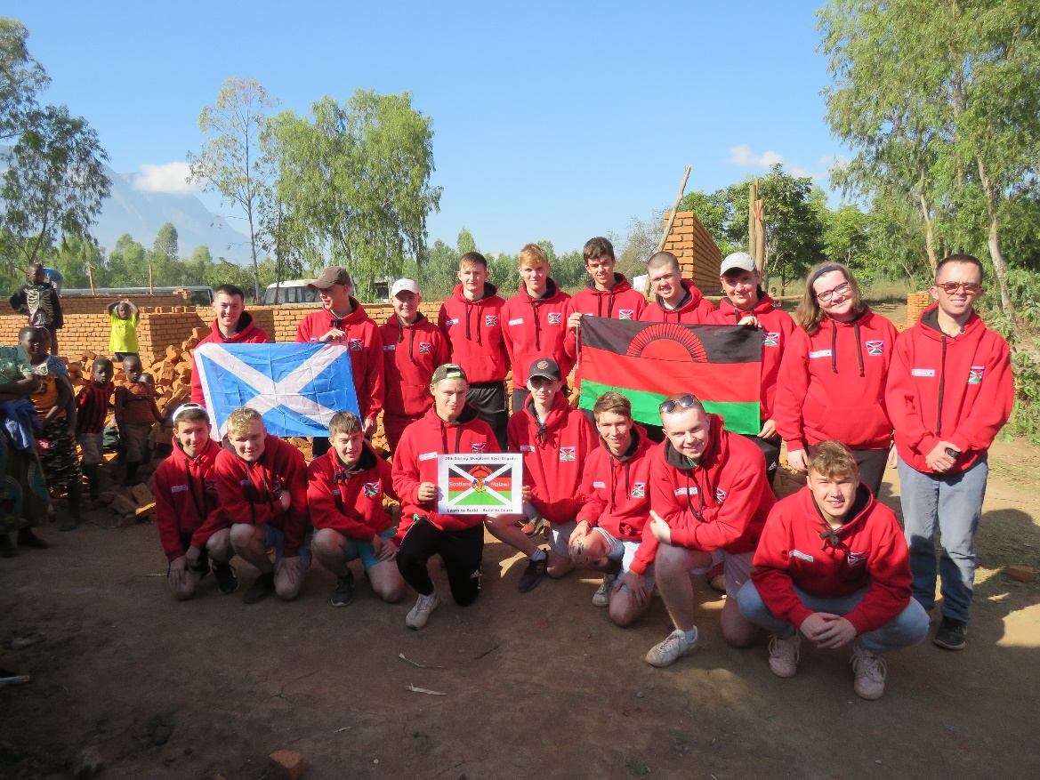

25th Stirling (Dunblane) Boys’ Brigade
Project Malawi 2019
Our Malawian Adventure

Introduction

In July 2019, a team of 25 from the 25th Stirling (Dunblane) Boys’ Brigade travelled to Malawi. They stayed in the Likhubula area for 2 weeks and during their time there they built 2 classrooms and renovated 10 others in Pasani Primary School.
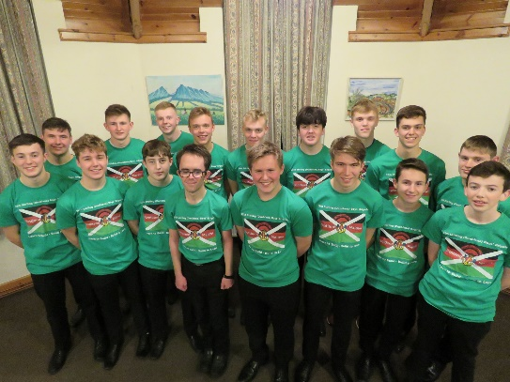
This was the culmination of a year of fundraising and hard work that involved all 17 boys and their families. They raised a phenomenal amount of money. A phenomenal amount.
This document describes what the team accomplished within their fundraising efforts and within Malawi. It will contain all the financial details of the project as well as provide some learning points that can be used by future projects.
I, personally, would like to thank everyone who made this project possible. I have never experienced generosity the like of which we experienced during this project. The community of Dunblane took the project to their hearts. The families and officers of the company were very supportive of the project as we tried to walk the tightrope of involving the whole company without dominating the programme. I would also like to thank the families of the boys who took part. Their hard work, dedication, enthusiasm made this project a joy to manage. I would like to thank Paul, Vanda, Ian, Graeme and Fraser for their tremendous amount of hard work during the fundraising and during the 2 weeks in Malawi. It was a huge amount of effort and responsibility but we worked well as a team. Finally, I would like to thank my long-suffering family. Often neglected and de-prioritised, they were my rock during the project.
Colin Anderson
Project Malawi Project Lead
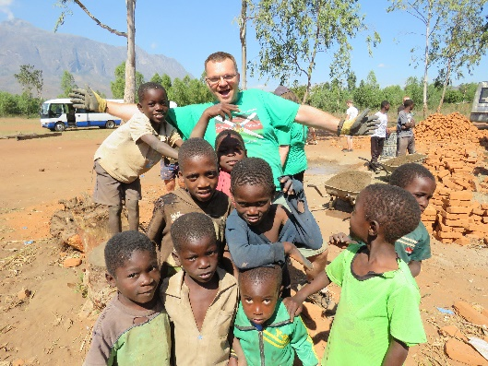

The Beginning

The Application and Selection Process
We approached the senior boys in the company (S4’s and up) to see what the level of interest would be. An information evening was held where parents and interested boys were invited to come and hear about our rough plans and what would be involved. We also gave details of what the application and selection process would be.
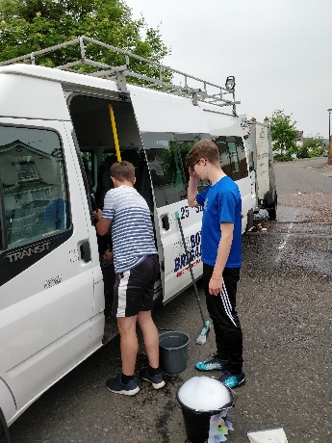
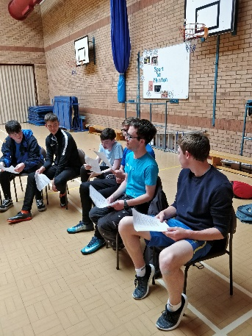
We created an application form that allowed the boys to state why they were applying and what they hoped to achieve. We then held a selection afternoon to test certain capabilities: commitment, teamwork, awareness and creativity. The afternoon consisted of several team exercises that were fun and challenging, discussions about “voluntourism” and an individual interview.
After a few discussions and several fallow-up conversations with some of the applicants, all 17 boys were selected. It was felt by all concerned that the application and selection process was well worth the time to do. It created a certain amount of formality that reflected the commitment the boys were going to sign up to.

Planning
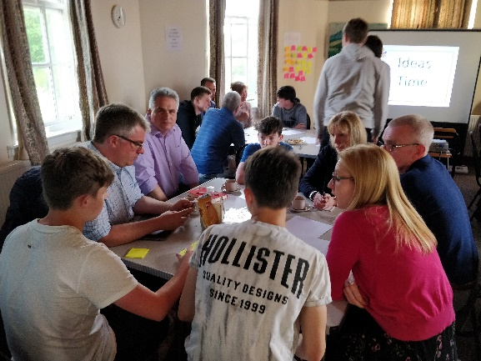
All parents and boys were invited along to contribute ideas and prioritise efforts. Although we had the basis of a previous project to run from, we were keen to get new ideas from this new group of boys and parents..
The meeting was a great success and started the process of forming a great parental team. The ideas were noted and a draft number was put against each idea to figure out how much we could raise.
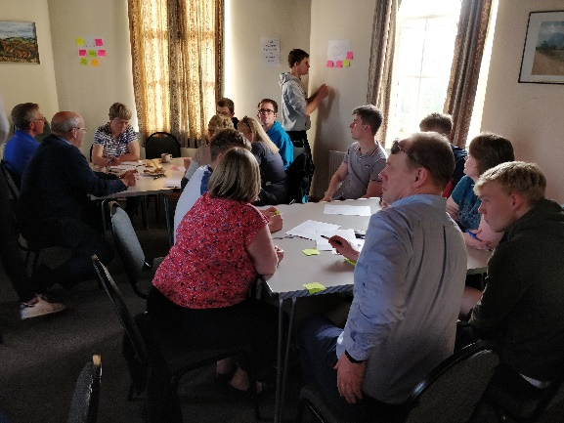
This planning session was held at the end of the BB year so all the boys were told that there was a nominal target for them all to raise at least £1000 on their own without any central organising.

Getting Ready
After the planning session was over, the organising could begin with several key items. Events were scheduled, rooms were booked and posters were created for a few events, the rules for the 100 club were agreed and plans were firmed up ready for the beginning of the new session. All during this time, the boys were working hard either with sponsorship plans or working in gardens and doing odd jobs. By enrolment evening at the end of August we were ready for launch.

Fundraising

Monthly Meetings
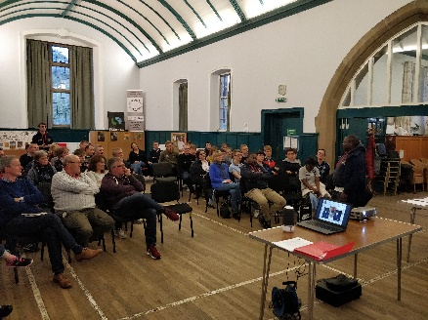
The fundraising efforts were managed in monthly intervals. Monthly project meetings were scheduled where all parents and boys were invited. These meetings would review the progress of the fundraising efforts and plan for the next month coming. The total raised would be shared and we would observe progress against plan. These meetings were also a good opportunity to invite along some guests who had experience in either Malawi or Classrooms for Malawi. These meetings were well attended and served the purpose they were created for.

Super Teams
One of the lessons learned from the last project was to create teams with specific aims in mind. These teams focussed on Publicity, Food and Nibbles, Gnomes and Bar and Tuck. One major improvement from the last project was that we were able to use WhatsApp to create groups and the communication worked very well These super teams worked well and allowed parents to get stuck in to the job at hand. After the team had a few events under their belt, the parental machine got into full swing. We started to know who was good at what, everyone started looking for fundraising opportunities and volunteers were easy to get.

Challenges
We did face several key challenges though:
Advance Ticket Sales – It was very hard to gauge ticket sales at each of our events as attendees would normally wait until the last few days to purchase a ticket. A few events had to be cancelled due to poor ticket sales.
Non-Project Family attendance at events - The main attendees at each event were the families of the team members. We struggled to sell tickets to other families within the company apart from a number of exceptions who we could rely on to attend.

Fundraising Performance

Big Ticket Activities
The individual sponsorships went very well. Although some boys did not do a major sporting sponsorship event, most did enough ‘chore’ type work to meet their £1000 target. The 100 Club was mainly supported by the project families and failed to penetrate further. We did still make £4173 which was below original budget and mainly due to the generosity of the project family team members who contributed their winnings to the project. The Lego school also failed to reach its target with only £324 raised out of an original target of £1000. The only group activity we failed to plan for was the group sponsorship activity. No idea was forthcoming from the team and it was decided that the individual sponsorship had probably saturated that source of funds. The big-ticket items raised £35727 against a £36000 target.
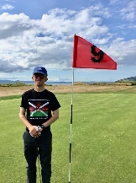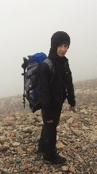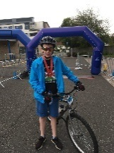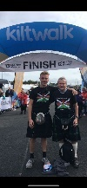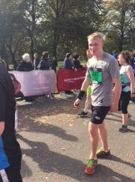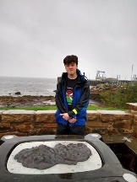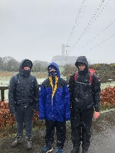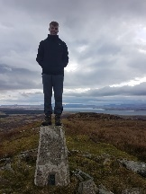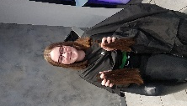

Events
We managed to run about half of the planned events in our original budget but the amount raised more than met the original target due to the success of the events we held. When we started to schedule the dates, we realised that we could not over populate the calendar with events. We tried to stick to one or two major events a month with a few minor ones depending on the opportunities that arose. We were also aware of the fact that it was mentioned that we held too many events last project which caused an issue with the community and it was perceived that our events got in the way of the company fund raising and they suffered because of that. As a result, we did not do any coffee morning fundraising and stayed away from any company fundraising. The amount raised at the Company fund raisers was monitored and did not suffer because of the Project Malawi fundraising (indeed, the Company coffers are in good shape compared to previous years). It is hoped that the Company benefits from the Project Malawi fund raising ideas in future instead of relying on the traditional routes that are not as profitable. The amount raised at the events was £26443 against the original budget of £15200
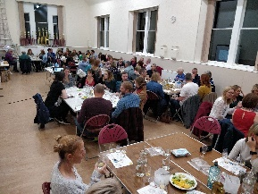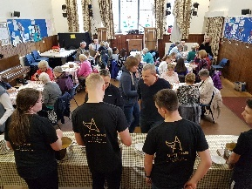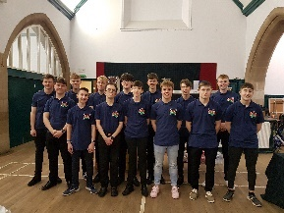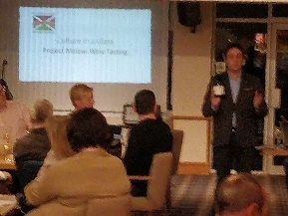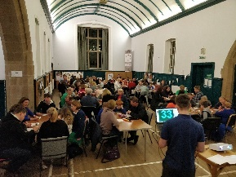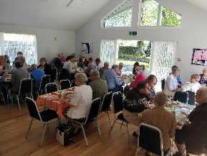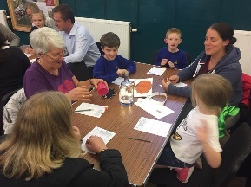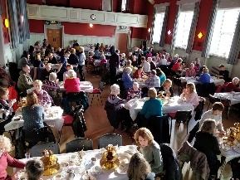

Sale Items
We didn’t do very well at selling the original items that we identified. The football cards, canteen cakes, band CD’s and coffee cups all failed to meet their targets by a long shot. However, the Andy Murray raffle and the donation cards met their target and fortunately, the gnomes smashed through their £4000 target to finally raise £5614. Total amount raised in this section was £9332 against an original budget of £9100 .
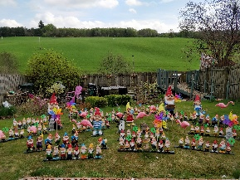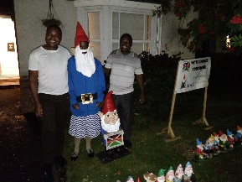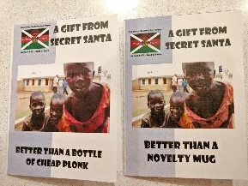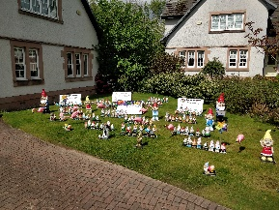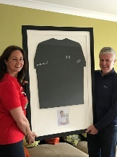

Trust Funds
We were very fortunate to receive some very generous donations from a number of funds, companies and generous donators. We were also very fortunate to be supported by the Church of Scotland Faithshare fund who offered us the cost of 4 flights, insurance and flights. The Dunblane Cathedral development fund also gave us a very generous donation. The total amount raised in this section was £25,380 against a budget of £10,000.

Unplanned items
The unplanned items amounted to £16,150 of the total. These included the retiring collection at the panto before the project kicked off, the golf competition which was enormously successful, the party bars and Fraser and Fiona’s parties, the sale of Colin’s whisky, the sale of Vanda’s pots, the retiral collection at the nativity the Big Christmas Push and the bag packing that was organised by Ross Pringle (not impacting any Company fundraising).

Preparation

Safety
Safety was our key consideration in any trip planning work. We consulted with previous trips and with CfM to put together a risk assessment document. This document was shared with all team members and their families to ensure that everyone was happy with our planned approaches. We also appointed two of the leaders to prepare and assemble a comprehensive first aid kit that would hopefully allow us to treat most scenarios that arose. Any spare medical kit would be left in the communities. We also collated details of hospitals. Inoculations were administered by both the NHS (for the free inoculations) and by Gecko Travel who ran 3 mobile surgeries and were also available at Stirling University if anyone missed a date. Gecko Travel also administered the Malaria tablets and we ensured that these were rigorously taken every morning (please note – they are not 100% effective as I checked when I came back).

Equipment
The equipment was bought online and was very cheap compared with local DIY stores. The acrylic paint was sourced via Siobhan Gouw who arranged this during the last project.

Preparation Meetings
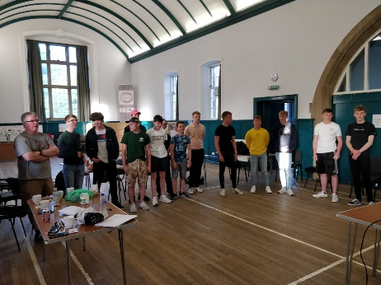
We held four preparation meetings on the Fridays between the display and our departure. These featured a language lesson, some team-building exercises, some worry sharing and some spiritual and mental preparation. We learned from last year to focus on our dancing and singing preparation. It was a chore at the time, but I think everyone was glad they went through it.

Travel Preparation
We were a bit jinxed… The closure of the main runway in Blantyre threw out our plans of the visa applications being managed by The Responsible Safari Company (RSC) although, our preparation in this area did pay dividends as we convinced the airport security guy in Lilongwe that we just pay our visa in Blantyre as it was madness there. All parents signed a consent letter allowing their child to travel with us and copies of all-important details with contact details were stored in a secure dropbox location that could be accessed by the communication contact in the UK and by us wherever we were. We also carried 2 copies of each consent form, each insurance certificate, passport details and the travel booking details.

The Trip

Travel
The travel was interesting. The bus to Manchester was very relaxing and a nice way to start as it was comfortable. We were fortunate to get checked in at Manchester Airport early on the condition that we signed up for Ethiopian Airways Sheba miles points scheme. We got through security and boarded the plane and everything was fine. We then spent 3 hours on the plane as there was an engineering fault. The boys were delighted as they watched Love Island on their phones but we were only worried about the connections. Fortunately, we made all connections and arrived safely in Blantyre with only 11 bags stuck at Lilongwe. They were attained a couple of days later but the boys all had emergency clothes and toiletries in their hand luggage. The other boys shared clothes where necessary.
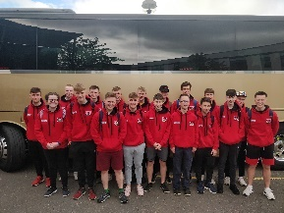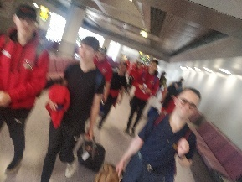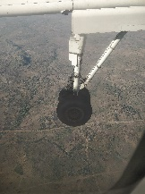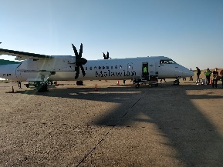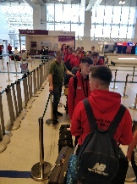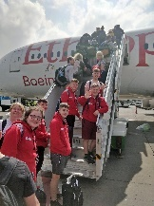

Accommodation
Likhubula Lodge was comfortable but basic. The boys occupied 2 dorms: one for the S6’s and one for the S5/4’s. There was another group also at Likhubula Lodge whilst we were there, but we managed to agree a pattern of timings to ensure we both got meals and rooms when we needed them. Three leaders stayed in rooms adjacent to the boys and the other leaders stayed in chalets 5-minute walk down the hill. Toilet facilities were basic and the showers were cold. Despite this we did not have any hygiene issues. Bottled water was always available for the boys to use for teeth brushing and for drinking at meals.
The accommodation at Kutchire Lodge was slightly better but there was still no hot water. However, Game Haven Lodge provided the boys with hot showers and most of the remainder of their spending money was spent on wifi.

Food
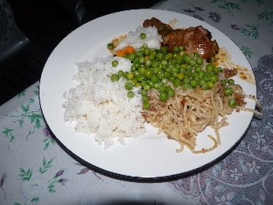
The food at Likhubula Lodge was basic but surprisingly plentiful. Breakfast consisted of porridge, fruit salad, toast, eggs and sausage. We were given packed lunches for lunch and then dinner consisted of either chicken and rice, beef or pasta. No complaints were made, and most boys ate everything in sight despite some of the food being quite repetative. We made a couple of trips to local shops so that they boys could also stock up on snacks.
We also went out for dinner twice during our stay in Likhubula. Once to a pizza place in Chitikale and once to Nancy’s Dream Restaurant where we were treated to a Malawian meal.
We sponsored the celebration dinner at Pasani school and invited the village chiefs and parents committee. The food at Kutchire Lodge and Game Haven Lodge was nice. It was mainly buffet based but plentiful.
The boys managed to survive on airplane food supplemented by snacks at the airport on the way home.

Logistics
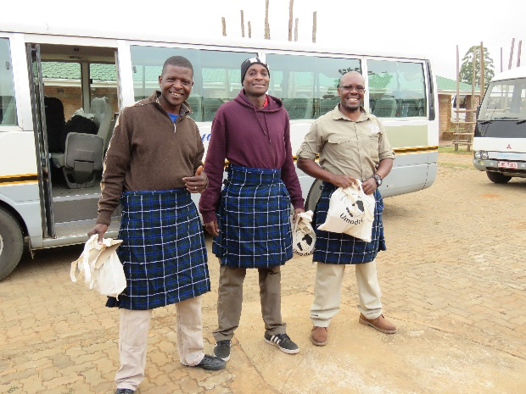
Our guide, Ozzie, and our two drivers, Newton and Arron, from RSC, managed all our logistics. We had two minibuses available to us which worked well. The minibuses were comfortable and well maintained.
Ozzie also facilitated our work at the schools with the builders when Dezie (Classrooms for Malawi) was not available. They acted as interpreters and helped during the one dispute that we had. They also managed the staff at Likhubula Lodge. They negotiated meal times and ensured that everything run like clockwork. We treated then as part of our staff and we planned the day’s activities with them.
Ozzie also took the lead when the boys need to visit hospital (numerous times) He suggested a suitable clinic in Mulanje and in Blantyre.
I cannot compliment the staff from RSC enough for their professionalism and management through the planning and execution of the project. Everything was thought about and ran very smoothly. They formed part of our team and became our friends.

Welfare
Safety was our top priority and we ensured that any mishap was treated as soon as possible. We had a few scrapes that required wounds to be cleaned and dressed.
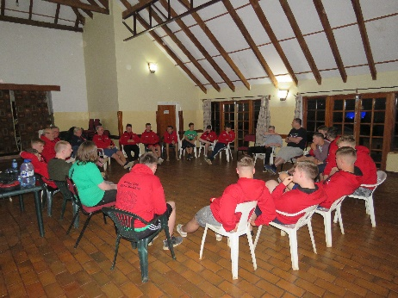
We kept an eye on the boys’ mental welfare very carefully given the change in culture and environment and everything else that occurred during the trip. Every evening we would have a meeting to discuss the matters of the day. The session was facilitated in such a way that all boys were asked to participate. Even the most introverted of boys were offering opinions and everyone enjoyed these discussions. I can honestly say that I have never experienced teenage boys express so many thoughts, feelings and opinions than I did during those sessions. We ended the majority of these sessions with a Top 5 session where a couple of boys would present their top 5 songs of all time. This provided a source of entertainment and a source of discussion during the day. We also had several great sing-a-longs.

The Welcome
The welcome at the school was mind-blowing. When we arrived, the learners swarmed the boys looking for high 5’s and just to touch their white skin. We had a welcome from the Headteacher and an overview on the Malawi education system from Dezie. We were then given a welcome dance and the boys sung a song in return. The boys then had some time to interact with the kids. Some sang songs with groups and some played football. All had a great time. The outpouring of appreciation was clear for the boys. They were treated like heroes and this spurred them on to do a great job in the following weeks.
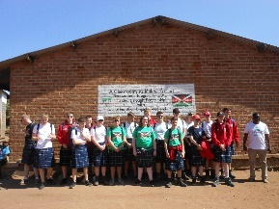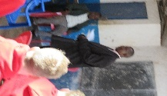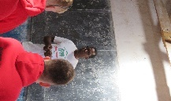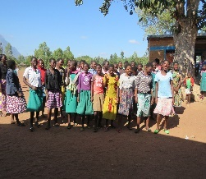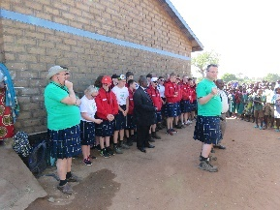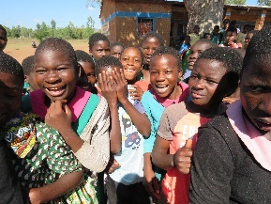

The Work
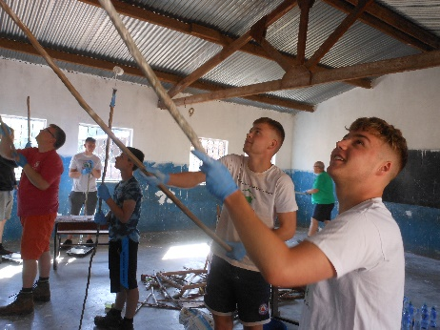
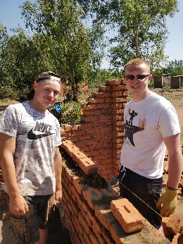
We split up into two groups So that one group could brick lay and one group could paint. The bricklaying was totally different from what we had practiced in Dunblane. The bricks were all uneven and it took some skill to choose the right bricks. We did not use spirit levels but used a string line instead. The builder oversaw all the work we did. The boys quickly got into the rhythm and we made great progress. We finished all the brick work that we could manage without going on any scaffolding within 3 days.
The painters had done a lot of preparation work for us before we arrived. They had limewashed the whole walls, so we only had to do 2 coats of white on the top half of the walls and then gloss the blue on the bottom half of the walls as well as the doors and windows. This was still hard work, but the boys got stuck in and made great progress. We also had time to put better murals up on the wall. Two boys prepared the stencilling and the rest of the boys followed with the acrylic paint (when they weren’t painting their shoes or their shirts)
In total, we managed to complete the painting in 10 classrooms in Pasani. The new classroom block will be completed by the start of the new term. The boys decided that they would like to dedicate the new block to the memory of Jane McManus, Headteacher of Newton Primary School, Dunblane.
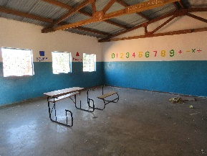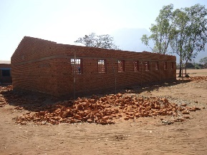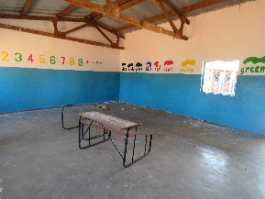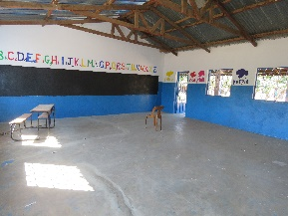

Experiences
As well as the painting, we tried to get the boys to experience as much of the local community as possible.
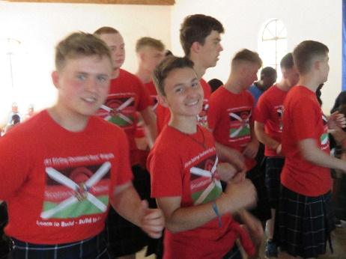
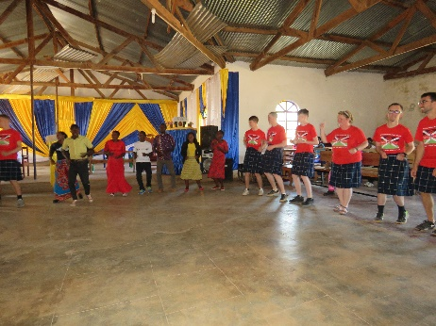
We also went to a 3½ hour Church service where we experienced a wonderful service full of song and dance. We provided our own entertainment in the way of a couple of songs. We then did our bit to follow in the footsteps of our missionary forefathers by introducing Nansato Church to some of Scottish culture – we taught them how to do the Slosh. The congregation were so welcoming, and we all felt right at home. They were very appreciative of our work, but they also gave us a level of fellowship that most of us have not experienced. They were very entertained by our dancing and our kilts. Interestingly, we went to Church in Blantrye a week later at St Michaels which was built by the Scottish missionaries and it was very similar to a traditional Scottish service with no singing and dancing. The boys were able to compare the two styles of worship – only one boy preferred the service in Blantyre. All the boys also picked up on a lot of the messages coming from the pulpit that did not sit comfortably with them. This was good to note and discuss.
After the Church service, we had lunch with the bursars that are funded by the Dunblane Likhubula partnership. They boys were scattered around and told to chat with their neighbour. This was an extremely worthwhile exercise which gave the boys a rich understanding of secondary school and of family life in Likhubula. We were very proud of the way the boys interacted with the bursars that afternoon. They did not need any encouragement to speak with them and they ended up playing games with them after lunch.
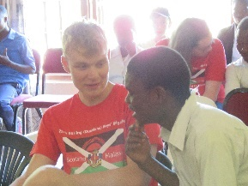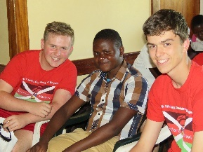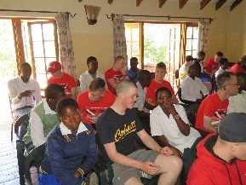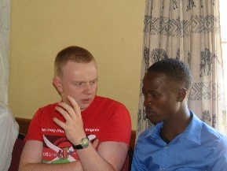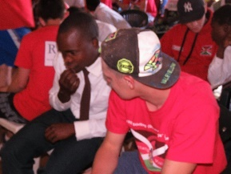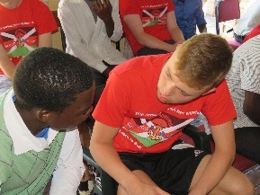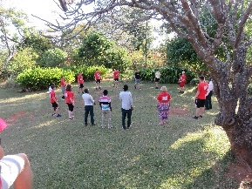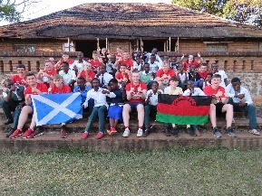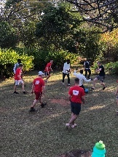

On Wednesday, we visited Green Malata Entrepreneurial village which was like a technical college. They taught 6-month courses on practical subjects in order to give Malawians a start in a specific career. They offered courses in hairdressing, tailoring, cooking, farming, IT, solar power and other forms of alternative energy. The village was very well set up and run and offered the partnership committee members who accompanied us a good idea of potential routes for bursars after their secondary education. One touching moment was when we met a group of deaf girls who were making reusable sanitary pads on sewing machines (old Singer peddles). Lewis in our group is also deaf but has cochlear implants. He was able to sign and lipread with the girls and have a conversation with them. They were fascinated by the implants. It was a great moment.
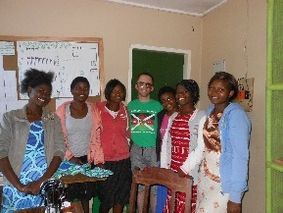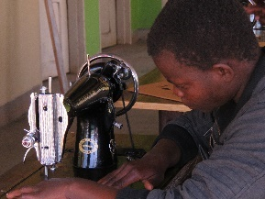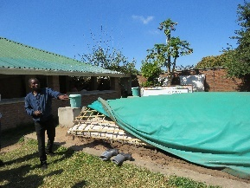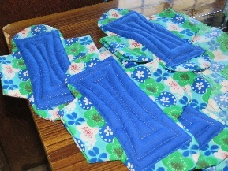

We went down early in the morning on Thursday to observe the World Food Programme distribution. The boys got stuck in serving the food and although most were looking forward to seeing how it works, most of the boys felt that it was really sad to observe despite being a great programme.
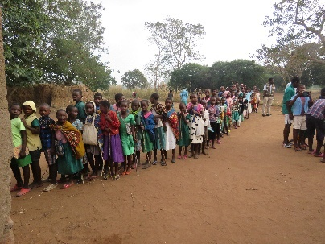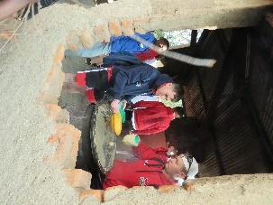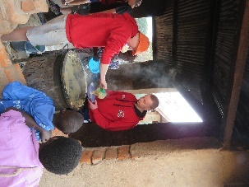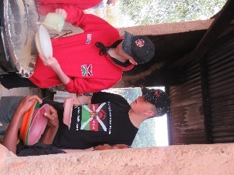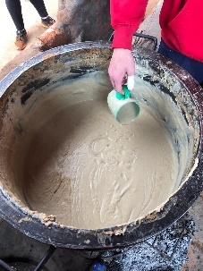

Later, that morning, we visited the Standard 7s with laminated photos of things from Scotland. We split the boys up around the Church where the S7s had just sat an exam and they had to use their best English to ask the boys questions. The kids were fascinated with the pictures although they did enjoy running around between the groups. It was a bit mad but enjoyable.
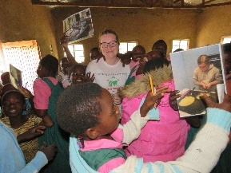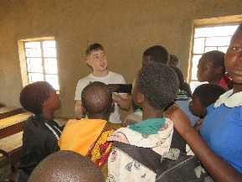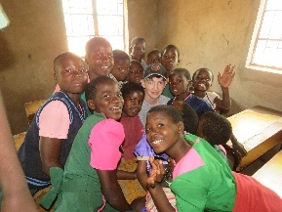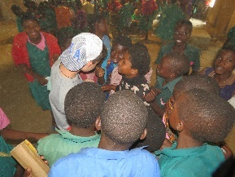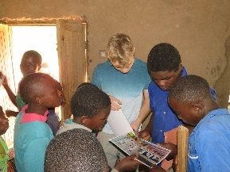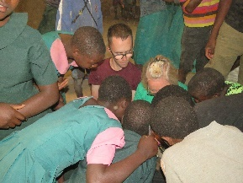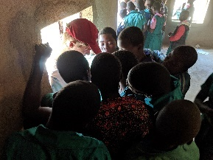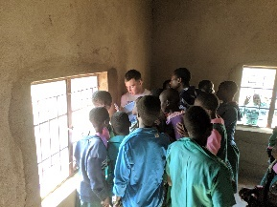
After the photographs, we were taken to visit a village and see what houses in Malawi are like. The first house we visited consisted of two buildings but one of the building which was about the size of one of the boy’s bedrooms housed 4 goats and 7 people. The boys also visited another house that had been damaged by the floods. They had spare bricks made from mud but no cement for the mortar to rebuild the houses. The boys were really impacted by that visit as it was poverty right in their face. It was clear that these people had nothing other than a spare set of clothes and that they survived with what they could grow in their gardens. It was an eye-opening experience, but all the boys commented on how the people were all still enormously happy and very proud to show us around.

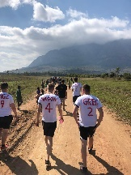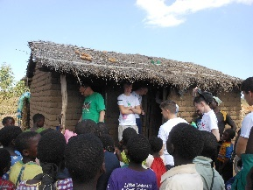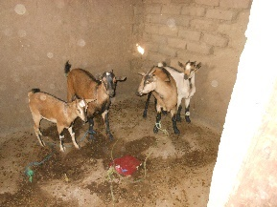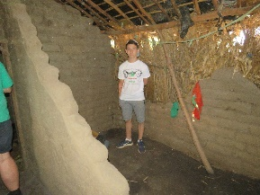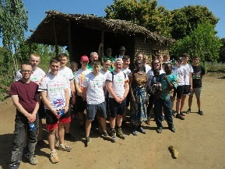
We had a celebration lunch in the school after our work was complete with the teachers, learner representatives, school committee, local chiefs and representatives from the Ministry of Education. After the necessary speeches, we shared a wonderful lunch cooked for us by the teachers. We then had a game of football with the staff that everyone really enjoyed (we won).
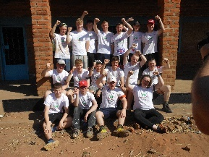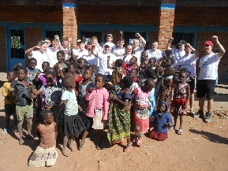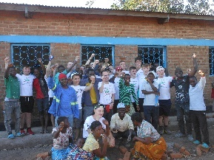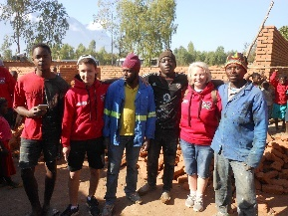
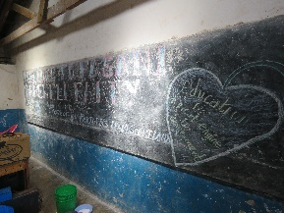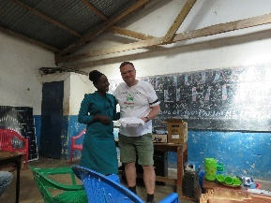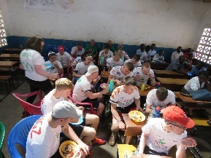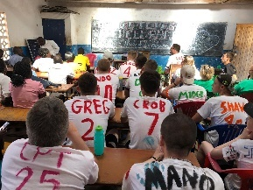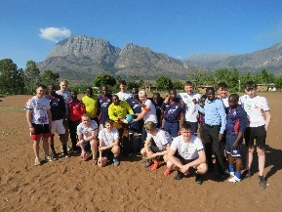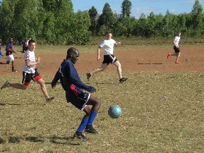

We then went to Lilongwe National Park to go on Safari at Kutchire Lodge. We went on a boat ride in the afternoon and then a game drive in the morning. The accommodation was basic and dorm style for the boys. It was a nice break but slightly hampered by a group of loud British Army guys who were also staying at the camp.
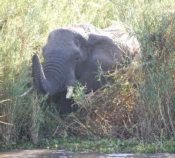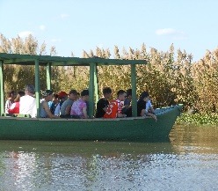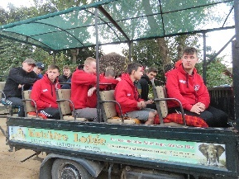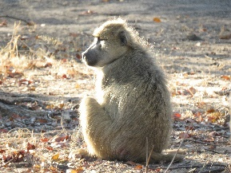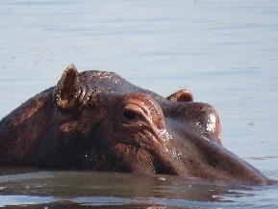
After our night at Kutchire we headed to Game Haven Lodge just outside Blantyre for 2 nights before flying home. The hotel was set in a reserve which had several animals. The accommodation and the food was nice. The boys really enjoyed the fact there were animals all around and that they could buy wifi with the money they had left over. There was a swimming pool, a golf course, mountain bikes and a driving range. Most of the boys took part in one of the activities. After Church on the Sunday, we went to the Malawi museum and a craft stall before meeting the Boys’ Brigade. Fraser and Ian had been at a very positive meeting with members of the BB across the whole of Malawi. This will hopefully prove to be very fruitful as they look to expanding the movement in Malawi. We then had a final dinner with Dezie and Kirsty Glen who is in Malawi with Project Trust. We said farewell to Ozzie, Newton and Arron then headed home.
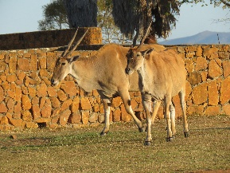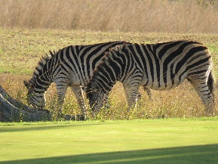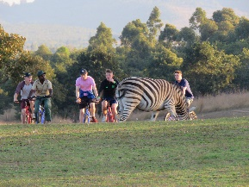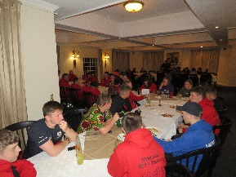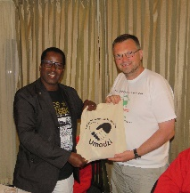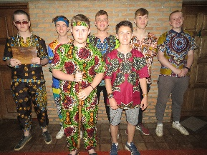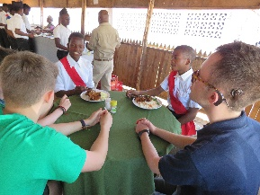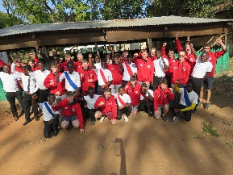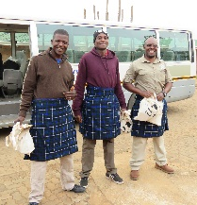

Financial Summary

Summary
We owe a great deal of debt to Fiona Shaddick who managed all the accounts and Gift Aid applications for us. Without Fiona, we would not have made the total we did.
In total, we raised £ 113,032.26. All this money was spent on project expenditure, travel and accommodation, Malawi expenses, monies for the repair work and Bursar books, torches and scholarships. We had a surplus of £2613.66 at the end of the project and we donated this to CfM for them to use on other projects.

Income
We categorised the income into the following groups
 | Original Budget | Monies Raised | Diff
Group Activities | 36,000 | 35,727.36 | -272.64
Events | 15,200 | 26,443.42 | 11,243.42
Sales | 9,100 | 9,332.30 | 232.30
Sponsors/Trusts | 10,000 | 25,379.84 | 15,379.84
Unplanned Items |  | 16,149.34 | 16,149.34
Total | 70,300 | 113,032.26 | 42,732.26

Details below
Group Activities | Original Budget | Monies Raised | Diff
Individual Fundraising | 25,000 | 31,230.36 | 6,230.36
100 Club | 5,000 | 4,173 | -827
Lego School | 1,000 | 324 | -676
Group Sponsorship | 5,000 | 0 | -5,000
Total | 36,000 | 35,727.36 | -272.64

Events | Original Budget | Monies Raised | Diff
Race Night | 1,000 | 0 | -1,000
Gin Tasting (3) | 750 | 6,520.74 | 5,770.74
Beetle Drive | 500 | 930.7 | 430.7
Whisky Tasting (5) | 4,000 | 10,266.32 | 6,266.32
Burns Night | 1,000 | 1,580.15 | 580.15
Bingo Night | 500 | 1,008.37 | 508.37
Wine Tasting | 750 | 1,091.89 | 341.89
Afternoon Tea (2) | 2,000 | 3,580.34 | 1,580.34
Sports Dinner | 1,000 | 0 | -1,000
Car Boot Sale/BBQ | 500 | 0 | -500
Say Yes to the Dress | 500 | 0 | -500
Easter Egg Hunt | 200 | 0 | -200
Craft Fairs | 1,500 | 0 | -1,500
Soup and Sweet (5) | 1,000 | 1,464.91 | 464.91
Total | 15,200 | 26,443.42 | 11,243.42
Sales | Original Budget | Monies Raised | Diff
Football scratch cards | 500 | 110 | -390
Canteen Cakes | 1,000 | 476.17 | -523.83
Donation Cards | 1,000 | 967.5 | -33.50
Band CD selling | 300 | 187.5 | -113.50
Gnomes | 4,000 | 5,614.29 | 1,614.29
Coffee Cups | 300 |  | -300
Andy Murray Raffle | 2,000 | 1,976.84 | -23.16
Total | 9,100 | 9,332.30 | 230.30

Sponsors/Trusts | Original Budget | Monies Raised | Diff
Trust Funds | 5,000 | 11,142 | 6,142
Individual donations | 5,000 | 14,237.84 | 9,237.84
Total | 10,000 | 25,379.84 | 15,379.84

Unplanned Items | Original Budget | Monies Raised | Diff
Golf Competition |  | 7,957.66 | 7,957.66
Golf Auction |  | 800 | 800
Panto |  | 945 | 945
Interest |  | 1.67 | 1.67
Pots |  | 729 | 729
Party Bars |  | 930.7 | 930.7
Calum's Dram |  | 1,580 | 1,580
Big Christmas Push |  | 2,036.6 | 2,036.6
Bag Packing |  | 600 | 600
Nativity |  | 433.46 | 433.46
Hoodies/Kilts diff |  | 135.25 | 135.25
Total |  | 16,149.34 | 16,149.34

Expenditure

Trip Expense | Amount | Details
Flights | 24,625 | All flights
Responsible Safari Co | 33,025 | Accommodation, Meals, Travel
CfM | 28,350 | Total cost of classroom repairs
Equipment | 1,338.29 | Trowels, brushes, rollers, trays, spirit levels, gloves, eye protectors, tape, medical kit, gifts, paints
Chichewa Lessons | 120
Cash to take with us | 2,368.85 | Dinners, guides, tips, lunches, medical expenses
Bursary Books | 3,100
Primary Teacher Scholarship | 6,000
Classroom for Malawi Donation | 2,613.66 | Donation for further CfM work
Bursar Torches | 660
Project Expenses | 10,831.11 | Hall bookings, Licences, whisky, gin, wine, tuck stock, T Shirts, Stationary, Gnome glue, catering (Burns, Afternoon Teas, Golf), bricks)
TOTAL | 113,031.91

Out of the £113,031.91 raised, £40,723.66 was used for charitable purposes. This is 36% of the total raised.

Feedback and Lessons Learned

Top 5 Memories

- Seeing the kids for the first time (10)
- Seeing the finished classrooms (10)
- Nansoto Church (10)
- Playing and singing with the kids (7)
- Building the classrooms – working as a team (7)
- Final day in Pasani – celebrations and football (7)
- Meeting the Boys’ Brigade (4)
- Meeting the bursars (4)
- Nancy’s Restaurant (2)
- Hanging out in the rooms (2)
- Seeing Mulange mountain
- Meeting Mr Nyambalo
- The wood carvers
- The feeding programme
- Village tour
- Painting
- Trying sugar cane
- Speaking with the guides
- When Ozzie said Thank You from the whole of Malawi
- Staying in a treehouse at the safari
- The look on Arrons face when we put the kilt on him
- Game Haven Lodge
- St Michaels Church

5 Biggest Challenges

- The work was hard (especially in the heat) (8)
- Kids asking for money and food and not being able to give them anything (6)
- Supporting our team members get through some challenges (5)
- Cold Showers (5)
- Similar food every day (5)
- Seeing how little Malawians have (5)
- Eating lunch at the school (4)
- Early mornings (4)
- Seeing the houses in such bad condition (4)
- Seeing the difference in wealth between rural Malawi and rich Malawians in Blantyre (3)
- Saying goodbye to our new friends (2)
- Seeing the state of the classrooms (2)
- Seeing the feeding programme
- Swallowing the pills
- Communicating with the kids at the school effectively and enthusiastically
- Long Church service
- Being swarmed by kids

What advice would you pass on?

- Grab the opportunity with both hands and make the best use of your time while you are here.
- Go in with an open mind and an attitude to learn a lot
- Get involved, don’t be shy, work as a close connected team and give the project 100% as the reward is amazing
- Write everything down in your diary and make the most of circle time
- Give it your all. You will only get back what you put in and you don’t want to waste your experience
- Take full advantage of the trip as it is a life changing experience
- Don’t worry about anything as it is all fine (like the food). Bring hand sanitiser.
- Be respectful, be helpful, be happy, have fun
- Be prepared to be up early and cold showers. Don’t be afraid of lack of phones etc plenty opportunity to charge. Bring a minimum of 2 speakers. Be prepared to see real poverty
- Get stuck in right from the start. Don’t be afraid to talk to any Malawians or ask questions. Try and learn some Chichewa before going on the trip. Make sure to write a journal to record memories
- Be prepared for the complete change and poverty levels found in Malawi and to be respectful of this. Also be ready for the hard work needed at the schools
- Definitely go and do the next project and see Malawi for yourself. Bring lots of old clothes, download lots of Netflix and spotify and bring a speaker. Be prepared for lots of hard work before you even get to Malawi. The more time you put in, the more you get out.
- Embrace the Malawian culture. Don’t be shy with the kids. Don’t worry about no wifi. I didn’t miss it
- Don’t be nervous about the actual trip. Just fully enter into everything while in Malawi. You will be warmly and enthusiastically welcomed everywhere you go
- Be prepared for the culture shock but enjoy playing with the kids as they are so happy

What would you change about this trip?

- Different safari or straight to Game Haven (6)
- The second church service (2)
- The journey was stressful with tight stopovers
- More interaction like with the bursars
- Go to classes for longer
- More bricklaying/painting practice
- Bursars lunch – would be good if we were paired up with one and got to know them well as it would give us a better understanding of how they live
- Don’t drive to Manchester
- Longer lies
- Teach the kids English

What projects do you think we should support next?

- Schools
- Something to help provide crops or water
- Toilets for Malawi
- More building projects
- Marys Meals/feeding programmes
- Do more than just one school so more kids get the benefit.
- Solar panels, books and feeding station kit
- Focus on one school
- Maybe houses

Any other comments?

- Good luck for next time – you have my full support
- This project has really changed me as a person for the better. At first at the beginning, 12 months ago, I was questioning whether I would actually enjoy the experience and if it was worthwhile. I can now say that I have thoroughly enjoyed this life-changing experience and that I will want to do it again. I’m honoured to have been selected and I couldn’t have asked for a better team to have been part of.
- This experience has been life changing and I hope that boys in future projects will have this too
- Thank you again to all the leaders. It is very valuable to have leaders and team members who have experienced Malawi before
- Thanks for the opportunity to be part of this project. I think it is the best thing I’ve ever done and would 100% recommend. The people of Malawi especially in Likhubula are so happy and welcoming
- Great experience and I would love to do something similar in the future. Thanks to all the leaders.
- Overall this was a very enjoyable trip that I will always remember. I would recommend to anyone thinking of doing something similar. Also two weeks was the right amount of time to be away
- Thank you to all the leaders for giving us the chance to experience a completely different culture and lifestyle. I think it will be lifechanging for all of us on this trip
- Overall I have enjoyed my time in Malawi & it’s an experience I will never forget for the rest of my life.

