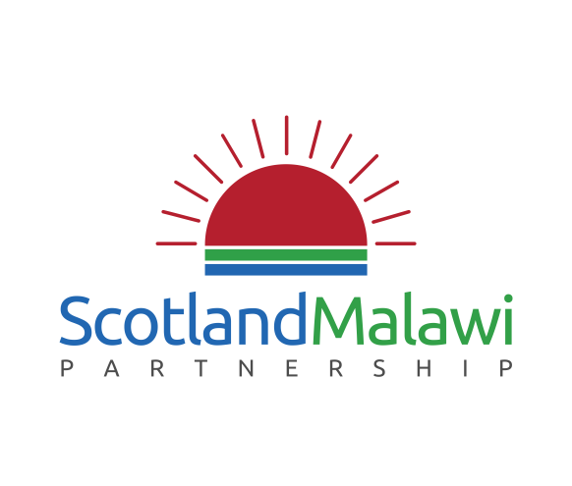
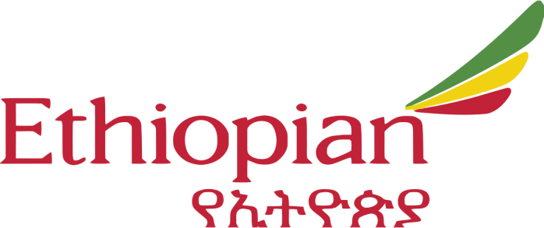

We are excited to announce that the Scotland Malawi Partnership has partnered with Ethiopian Airlines to give our members the opportunity to win a free return flight to Malawi!
We know that all of our members are working hard to develop, maintain and grow their links with Malawi, so what better way to champion these partnerships than by flying (for free!) to Blantyre or Lilongwe? Whether you are a frequent visitor, or you have been wanting to see all that the Warm Heart of Africa has to offer for the first time, this is the perfect opportunity to make your trip to Malawi unforgettable. After all those newly-formed partnerships at our recent AGM in Edinburgh, we can imagine that no further incentive may be needed!
All you have to do is complete this short survey where Ethiopian Airlines will be asking you about your travel preferences for getting to Malawi:
ENTER HERE >>
The survey is both quick and easy, and it is currently running until 31st October.
The winner will be announced on the 1st of November 2017, so don’t delay – complete it now for your chance to win this once-in-a-lifetime prize!
Terms and conditions
Please note that you must be 18 or older and a UK resident to enter this survey.
Entries from Scotland Malawi Partnership Members will be entered into the prize draw.
The prize offer is one return air ticket from Heathrow to Malawi (Lilongwe or Blantyre) valid for travel during low/shoulder seasons (1 Jan-2 Mar & 09 Apr-30 Jun & 25 Aug-30 Nov), and for a maximum stay of 3 months. Passengers can fly in to Lilongwe and return from Blantyre or vice versa. Only government taxes are payable, currently approx. GBP143. Tickets must be issued by 25th June 2018. Tickets have no cash value and are non-transferrable/refundable once issued. Travel only permitted on Ethiopian (ET) operated services. All other rules per applicable ET tariff.

